**FEATURES**

1. Keep records/scores of the students with security control
2. Compute grades automatically
3. Display level of proficiency and rank number.
4. Generate summary of quarterly grades.
5. Print quarterly grades and summary of quarterly grades.
6. Display rank of the students according to their computed grades.
7. Can add/ store one or more subjects and sections within the school year.
8. Backup feature
9. Names are separated from male and female, should be sorted alphabetically.
10. Can view the grade sheets and summary of quarterly grades, progress or improvement of the students using mobile phone and can be filtered by:
11. Rank number(ascending & descending)
12. Written Works (Lowest to highest/highest to lowest)
13. Performance task (Lowest to highest/highest to lowest)
14. Quarterly assessment (Lowest to highest/highest to lowest)
15. Quarterly grade (Lowest to highest/highest to lowest)
16. Final grade (Lowest to highest/highest to lowest)

**COMMENTS**

1. Grade level – dropdown list
2. Subject – dropdown list

* 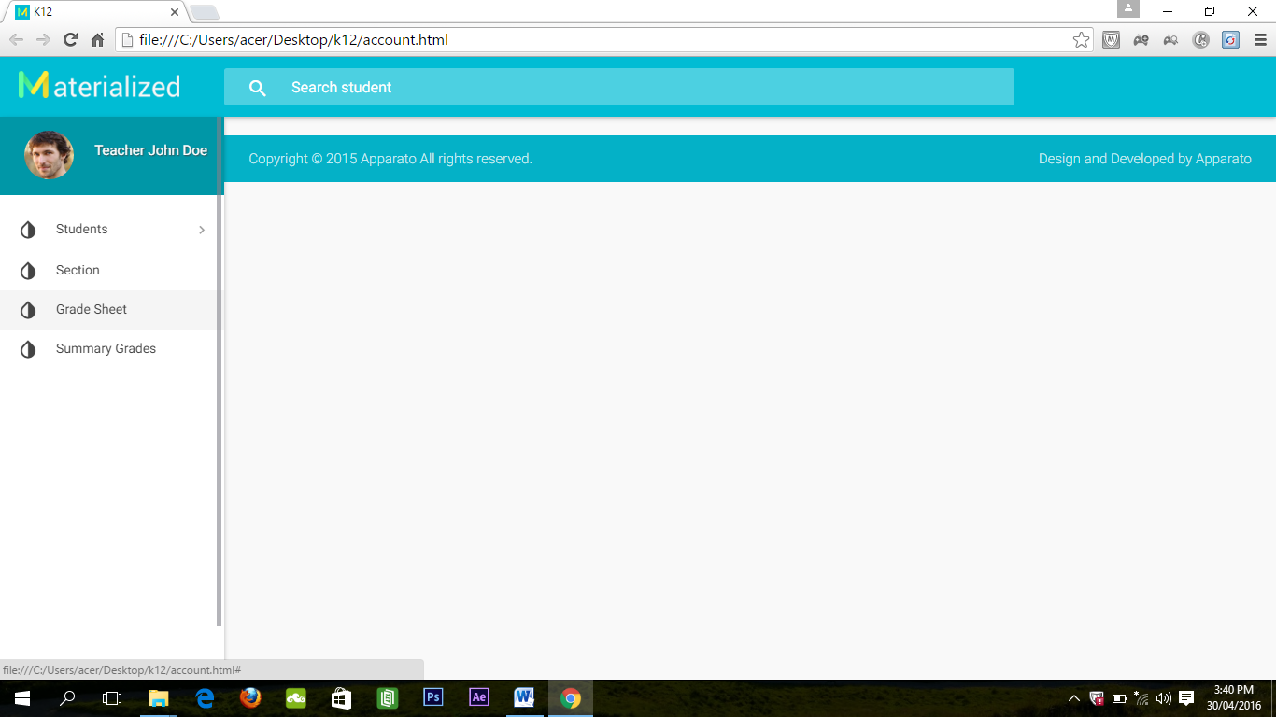Percentage/breakdown depends on subject (please see the deped order)

1. **Grade Sheet** Option

**School Year**

**Subject**

**Section**

1st quarter | 2nd quarter | 3rd quarter | 4th quarter | summary of quarterly grades